**Meridan State College**

**Queensland State School Reporting**

**2014 School Annual Report**

|  |  |  |
| --- | --- | --- |
| 1733 | Postal address | PO Box 3908 Caloundra DC 4551 |
| Phone | (07) 5490 2666 |
| Fax | (07) 5490 2600 |
| Email | the.principal@meridansc.eq.edu.au |
| Webpages | Additional reporting information pertaining to Queensland state schools is located on the [*My School*](http://www.myschool.edu.au/) website and the [Queensland Government data](http://data.qld.gov.au/) website. |
| Contact person | Mrs Julie Kornmann – Executive Principal |

**Principal’s foreword**

## Introduction

Welcome to the School Annual Report for Meridan State College. The intention of this report is to provide parents, staff, students and the community with a comprehensive but concise picture of our College and the progress we have made towards achieving our goals for the past year. In 2014, our ninth year of operation, our goal continued to be the establishment of our College as a safe, supportive and stimulating learning environment in which our students can achieve their potential as creative, active and respected citizens in an evolving global society. The success of our progress towards achieving this goal is evidenced by the continued rapid growth of the College, the results of the systemic testing of student learning outcomes, the outstanding results of our Student, Parent and Staff School Opinion Surveys and the reputation we are already achieving for providing excellence in education.

## School progress towards its goals in 2014

|  |
| --- |
| **Highlights of 2014:**   * Meridan’s selection as an Independent Public School was recognition of the College’s readiness to accept greater autonomy for the leadership and management of our unique educational context. The granting of this status also enabled the school to access a more extensive and informed contribution from the parent and broader community to the decision making process of the College at a strategic level. * A very successful Discipline Audit conducted during the year assessed Meridan SC as Outstanding or High in all five domains (Compliance Medium). The Auditors commended the College on its strong focus across the sub-schools on the development of a positive learning culture featuring high expectations and high standards of behaviour. * As a Pilot School for Junior Secondary, 2014 was a very busy year for Meridan with teachers from across Queensland visiting to observe classrooms to learn how to successfully integrate Year 7 into secondary school in preparation for the Flying Start initiative of 2015. Meridan’s signature pedagogy of Flexi Learning, which is designed to address the specific needs of young adolescents in this phase of their education, was a focus of these visits. Our staff also shared how Meridan has embedded the six Principles of Junior Secondary in daily practice through participating in video programs and presenting at conferences. * Once again Meridan achieved commendable Year 12 exit outcomes with 100% students achieving a Queensland Certificate of Education and 100% also receiving a Vocational Education Certificate. The Overall Performance (OP) results were 72.5% achieved OP 1-15 and 96% of eligible students received a Queensland Tertiary Admissions Centre (QTAC) offer. In 2014, approximately 60% of our graduating students continued in further education and training while a further 30% gained employment in the year they left school. * Our whole College focus on Literacy and Numeracy in 2014 achieved significant improvement in a number of areas with the results of systemic testing showing continual improvement on previous years. Our unrelenting focus on enhanced academic outcomes was evidenced in the individual achievements of many of our students in the ICAS Maths, English and Science competitions. * In Science high performing students from Meridan were selected to participate in the National Youth Science forum in Canberra, the Queensland Youth Science Forum in Brisbane, and numerous events at the Queensland and Sunshine Coast Universities. Of particular note, seven of our Year 7 students tied for 1st, 2nd and 3rd places at the Science Research Awards at the Sunshine Coast University. * Meridan’s Program of Excellence in the Performing Arts also achieved outstanding success in Music, Choir and Dance. Our musicians performed at Creative Generation and also at Fanfare where they received a Gold Award and they were also the North Coast Regional Finalist with the best P-12 Ensemble. Our Meridan Dance Troupe achieved great success in the Dance Star Championships winning 4 Gold and 1Silver at State level and 1 Silver and 1 Bronze at the National Titles. * The outstanding opportunities provided to students by our Technical Trade Training Centre was recognised by first being selected as a Showcase Regional Finalist and then winning the Showcase State Award for Excellence in Senior Education for Queensland. * Meridan’s successful selection for the Federal Government’s Empowering Local Schools Initiative recognised our College’s commitment to connecting with our parent community by exploring opportunities through the digital media to enhance local decision making. Participation in this program also allowed Meridan to establish a Contemporary Learning Hub to provide face to face and online professional development to our own staff and also to staff in schools across Queensland. This innovative initiative continues to promote the profile of our College as a leader in 21st Century teaching and learning. * A state of the art, purpose built teaching block of 10 classrooms was constructed in readiness for the increase in enrolments with the ‘Flying Start’ - Year 7 in High School initiative in 2015. |
|  |

## Future outlook

|  |
| --- |
| The Key Areas for Improvement as defined in the 2015 Operational Plan are to:   * Continue with Whole of College focus of improving student learning outcomes in literacy and numeracy through the analysis and use of data in planning classroom programs * Support the continued implementation of the Australian Curriculum (Arts; HPE; Civics & Citizenship; Economics and Business) * Continue the implementation of the Junior Secondary Agenda and signature pedagogy * Embed the Pedagogical Framework and P-12 Literacy and Numeracy Plans in classroom practice * Meet students individual needs through the implementation of P-12 Class Differentiation Plans * Implement the Independent Public Schools initiative in response to student and community needs * Implement and engage in regular data review cycles as articulated in the Whole of College Data Plan * Embed eLearning across the curriculum through the facilitation of the Contemporary Learning Hub * Create innovative and efficient organisational, physical and resource structures that are responsive to the needs of a new and growing P-12 school context * Build authentic opportunities for engagement in response to the Parent and Community Engagement Framework |
|  |

|  |
| --- |
| Our school at a glance |
|  |

## School Profile

Meridan State College is a co-educational state school which opened in January 2006 and which caters for students from Prep to Year 12. It has already established a reputation as a high performing school with an emphasis on quality teaching and high standards of behaviour in a safe, supportive environment.

The College currently provides a quality education for students from Prep to Year 6 in Primary School, Year 7 to 9 in Junior Secondary, and Year 10 to 12 in Senior Secondary. The College consists of three sub schools, each of which has its own campus and identity within the site but is aligned with the direction and focus of the College entity. A dense rainforest divides the site creating an attractive environment and providing a separation of the sub schools. A boardwalk which transverses the rainforest links the sub schools and provides for unique learning experiences for our students in a beautiful, natural environment.

The College has experienced continual growth since it opened and the total enrolment as of 30 June 2014 was 2300, an increase in growth of approximately 200 students since the same time the previous year.

The rationale behind the sub school structure is embedded in a body of research which indicates that small schools within a larger school have the potential to significantly enhance educational outcomes for students while facilitating the transition through the different phases of learning. The sub school structure also enhances the positive aspects of a small school while increasing access to the extensive facilities and resource efficiencies of a large school.

### While Meridan is very much a College of the future, we place great importance on ‘old fashioned’ values, such as good manners, considerate behaviour and pride in our College and ourselves. We believe that education is a partnership between the home and the school, and we greatly value parent involvement as fully as time and commitments allow. The parent community are very supportive of our endeavours to provide the very best educational experience possible for our students, in a safe, secure and happy environment.

**Coeducational or single sex: Coeducational**

**Year levels offered in 2014: Prep Year - Year 12**

**Total student enrolments for this school:**

|  |  |  |  |  |
| --- | --- | --- | --- | --- |
|  | Total | Girls | Boys | Enrolment Continuity  (Feb – Nov) |
| 2012 | 2070 | 1062 | 1008 | 95% |
| 2013 | 2212 | 1132 | 1080 | 95% |
| 2014 | 2300 | 1182 | 1118 | 95% |

Student counts are based on the Census (August) enrolment collection.

## Characteristics of the student body:

The majority of students’ families are mid socio-economic status with the trades being the most common occupational background. As Meridan is located in a rapidly growing area of Caloundra and is surrounded by new housing developments, many of the students have recently experienced a move from another location, whether from within Queensland, from other states or from overseas. The College has a range of programs in place to ensure the students experience a smooth transition into their new school environment. Due to an Enrolment Management Strategy which restricts the catchment area for enrolment, students generally live in relatively close proximity to the College.

## Average class sizes

| Phase | Average Class Size | | |
| --- | --- | --- | --- |
| 2012 | 2013 | 2014 |
| Prep – Year 3 | 23 | 23 | 24 |
| Year 4 – Year 7 Primary | 26 | 27 | 26 |
| Year 7 Secondary – Year 10 | 24 | 26 | 25 |
| Year 11 – Year 12 | 17 | 17 | 18 |

## School Disciplinary Absences

| Disciplinary Absences | Count of Incidents | | |
| --- | --- | --- | --- |
| 2012 | 2013 | 2014* |
| Short Suspensions - 1 to 5 days | 186 | 202 | 230 |
| Long Suspensions - 6 to 20 days | 16 | 18 | 2 |
| Exclusions# | 0 | 0 | 0 |
| Cancellations of Enrolment | 0 | 0 | 0 |

# Exclusion is an abbreviated title which reflects suspensions with recommendations for exclusion, which may result in an exclusion or be set aside through an appeals process.  
* Caution should be used when comparing 2014 data with previous years SDA data as amendments to the disciplinary provisions in the Education (General Provisions) Act 2006, passed in late 2013, created a time series break.

## Curriculum offerings

**Our distinctive curriculum offerings**

Primary School:

* Comprehensive curriculum based on Australian Curriculum, and the P-12 Curriculum Assessment and Reporting framework
* Introduction of new curriculum areas by introducing an Arts specialist and a teacher that focuses on the area of Health
* Curriculum plans developed in collaborative teaching teams termly to ensure consistency and excellence within all programs
* Signature practice of personalising learning through learning goals, differentiated activities and extension activities embedded within units of work
* Creative use of ICTs within curriculum programs to develop 21st century learners and engagement in our Infinity lab
* Key focus on literacy and numeracy skills across all key learning areas.
* Consistency by teachers using the Meridan Way of teaching Reading & Numeracy
* Showcase 2015 entry highlighting our Numeracy program
* Focus on personalized learning for students, precision in program implementation and professional teams working together to cater for our students’ needs.

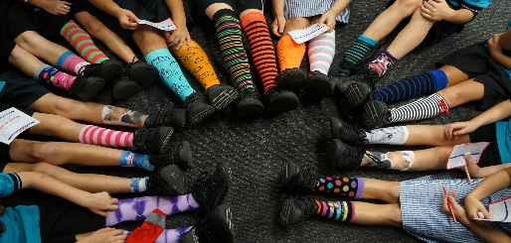

Junior Secondary School:

* Comprehensive curriculum based on National Curriculum and P-12 Curriculum Assessment and Reporting Framework.
* Signature practice of ‘flexi learning’ involving team planning, collaborative teaching and differentiated learning.
* Individual Curriculum Plans and Learning Enhancement Programs to support needs of different learners.
* ‘Level Up’ Gifted and Talent Conference and Master Classes to cater for high performing student in academics and performing arts.
* Multi-disciplinary project-based learning across Technology and Arts curriculum.

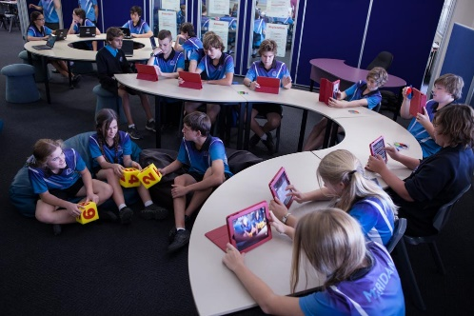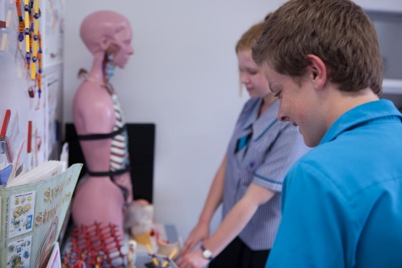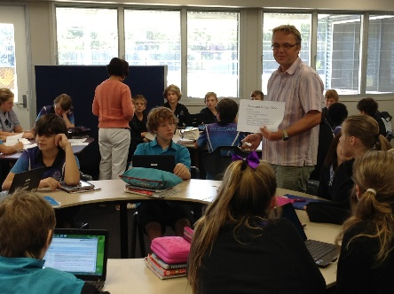

Senior Secondary School:

* A focus on personal, performance and career readiness pathways as essential to ensuring all students are achieving success.
* An individualised and multi-layered approach to planning, monitoring and tracking student achievement, performance and educational and career development.
* Comprehensive academic and vocational curriculum offerings resulting in relevant pathways and qualifications for all senior school students.
* Active partnerships with industry, community, business and external educational providers to maximize learning and vocational pathways for students including traineeships, school-based apprenticeships, university study and certificate courses.

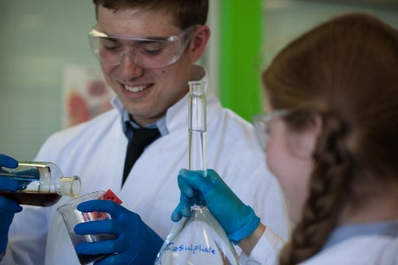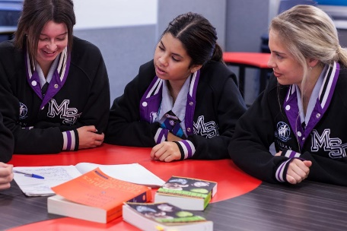

**Extra curricula activities**

Primary Campus:

* Performing Arts Program: Year 6 Arts Elective Program, Choirs, Instrumental Music Program, Fanfare, Guitar.
* Sport: Year 5-6 Interschool Sport Program, Yr 1-6 Swimming Program, Year 5-6 Surf Skills, Year 5-6 Camping program
* Academic: ICAS Competitions, Optiminds, Partnership with Brisbane school of distance education, Voices on the Coast, Year 6 Arts elective program, Enrichment programs

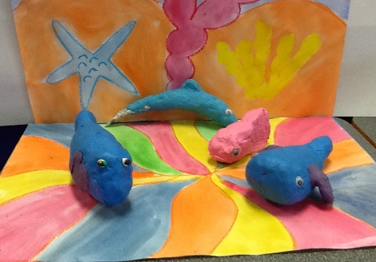 

Secondary Campus:

* Performing Arts Program: Impact Dance Team, Drama Club, Choirs/Singing Groups, Instrumental Music Program, Fanfare, Media Club, TFT Dance Sport Championships, Programs of Excellence
* Sport Program: Year 7-9 Interschool Sport Program, Swimming/Cross Country/Athletics Carnivals, Participation out of school competitions e.g. Netball, Touch Football, Rugby League, Basketball, Aerobics
* Academic: ICAS Competitions, Science Competitions, Public Speaking: Debating Competitions, Rotary, Lions Youth of the Year, Student Leadership, College Magazine, Scholarships, Tutorials, International Program

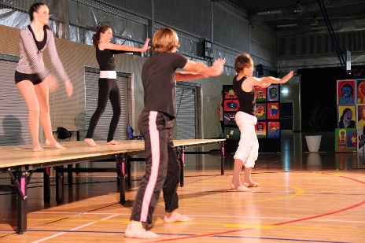

**How Information and Communication Technologies are used to assist learning**

Primary Campus:

* In the Primary Campus, Meridan has taken a blended approach when rolling out ICTs within our classrooms. Throughout their P-6 journey, students have access to a broad range of devices including interactive white boards, touch screen computers, laptops, iOS devices, robots and data collection devices. Students and teachers also have access to a large collection of high quality software applications and online tools that support students to meet the demands of ACARA units as well as developing digital literacy and media authoring skills.
* Students in P-3 receive specialist technology lessons which support them to develop their digital literacy and fluency. Students develop skills in the use of a broad range of tools and applications as part of this program. By year 3, students have had rich digital experiences including creating customised digital maps, making models in 3D modelling applications and authoring files and presentations in Office applications and iOS apps.
* Our Primary Campus has subscriptions to online learning and assessment platforms which enable our staff to differentiate learning for students and track student engagement and outcomes with these tools. Digital devices and pedagogies are used within our classrooms and LDC to support students with disabilities or learning difficulties.
* Through our collaborative unit planning model, opportunities for using digital pedagogies are identified by Year level teams with the support of our Head of Curriculum.  During and after planning, Year level teams and individuals identify skills with which they need further support. This support is provided through peer tutoring, our Primary ICT specialist teacher or through our onsite professional learning centre, the Contemporary Learning Hub.

Secondary Campus:

* BYODx Program in Year 7 and small group Year 12 student trial.
* One-to-one laptop program available to students in Years 9-12.
* Ipad, Ipod and Laptop trolleys available for use in teaching blocks.
* Access to computer labs.
* Delivery of curriculum through a range of digital pedagogies including online learning spaces (virtual classrooms, blogs), applications (e.g. Ipod/Ipad Apps), software (e.g. CAD), global communication (wireless), email (staff/student dialogue).

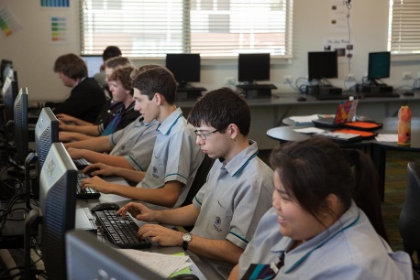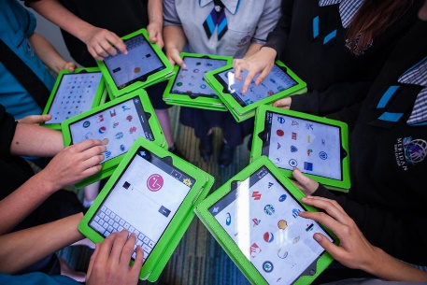

**Social Climate**

Meridan State College’s Vision, to “Inspire Excellence in Diverse and Creative Learners’, and Values are clearly outlined in the College Statement of Purpose, and are embedded in the culture through a range of approaches and strategies.

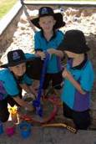Meridan’s Responsible Behaviour Plan for Students outlines the values, standards of behaviour and responsibilities of all members of the College community in promoting positive behaviour and supporting student learning. It incorporates the College’s positive and proactive approach to rewarding appropriate behaviour while ensuring the rights of all students to learn and feel safe. High expectations, equity, inclusiveness and respect for self and others are key features of schooling at Meridan. The effectiveness of the College’s management of behaviour was recognised this year in the Report of the Discipline Audit with Meridan achieving ‘Outstanding’ or ‘High’ for all elements in the 5 domains (Compliance Medium).

Meridan is a FISH! philosophy school. This program is considered to be particularly relevant for our adolescent students and is embedded in practice on the secondary campus. The FISH! philosophy is the key to promoting successful human relationships through the application of guidelines for behaviour and attitude. It is a set of simple, interconnected principles that can be tailored to suit the individual and the context. They are: Play, Choose your Attitude; Make their Day and Be There and through practice these principles promote positive relationships at work, school and at home.

The FISH! philosophy lives through a number of pastoral care programs provided by the College, such as You Can Do It, Rock and Water, Restorative Practices and the 5 C’s – Courage, Compassion, Courtesy, Collaboration and Choice. These programs are designed to promote co-operative and harmonious relations leading to success in learning.

Our College has a ‘Community’ structure and all students and staff belong to one of the four Communities. The Communities are named after elite sports people (Bradman, Freeman, O’Neill and Rafter) who are known not only for their sporting prowess but also for their charity and humanitarian work. The Community structure provides vertical social groupings, a supportive environment and an enriched pastoral care program for students. It allows for greater staff, parent and student interaction and promotes positive relationship building across all sub schools for staff and students. This structure is supported by research which indicates that smaller groupings within a larger educational organisation have the potential to significantly enhance educational outcomes for students. It also promotes a deeper sense of belonging for all involved in our school community and pride in our College.

Developing the leadership skills of our students is a focus for the College. At Meridan we believe that all students have the potential for leadership and each of the sub-schools have leadership programs and structures to promote leadership aspirations and potential. Leadership camps and programs conducted by external leadership consultants are a feature of our annual leadership development program and provide a platform for the selection of sub school and College leaders for the following year. In Junior Secondary students explore leadership through a ‘Steps to Success’ Program and our Senior students engage in a ‘Pathways to Success’ program which provides them with the study skills and independent work practices to prepare them for tertiary study or employment.

**Parent, student and staff satisfaction with the school**

| **Performance measure** |  |  |  |
| --- | --- | --- | --- |
| Percentage of parent/caregivers who agree# that: | 2012 | 2013 | 2014 |
| their child is getting a good education at school (S2016) | 95% | 92% | 90% |
| this is a good school (S2035) | 99% | 96% | 87% |
| their child likes being at this school* (S2001) | 91% | 93% | 88% |
| their child feels safe at this school* (S2002) | 93% | 100% | 94% |
| their child's learning needs are being met at this school* (S2003) | 87% | 85% | 84% |
| their child is making good progress at this school* (S2004) | 93% | 81% | 83% |
| teachers at this school expect their child to do his or her best* (S2005) | 99% | 92% | 96% |
| teachers at this school provide their child with useful feedback about his or her school work* (S2006) | 91% | 84% | 86% |
| teachers at this school motivate their child to learn* (S2007) | 89% | 88% | 86% |
| teachers at this school treat students fairly* (S2008) | 89% | 96% | 84% |
| they can talk to their child's teachers about their concerns* (S2009) | 95% | 93% | 85% |
| this school works with them to support their child's learning* (S2010) | 95% | 93% | 84% |
| this school takes parents' opinions seriously* (S2011) | 92% | 88% | 81% |
| student behaviour is well managed at this school* (S2012) | 88% | 88% | 75% |
| this school looks for ways to improve* (S2013) | 97% | 100% | 88% |
| this school is well maintained* (S2014) | 98% | 100% | 97% |

| **Performance measure** |  |  |  |
| --- | --- | --- | --- |
| Percentage of students who agree# that: | 2012 | 2013 | 2014 |
| they are getting a good education at school (S2048) | 95% | 98% | 96% |
| they like being at their school* (S2036) | 88% | 94% | 91% |
| they feel safe at their school* (S2037) | 92% | 96% | 96% |
| their teachers motivate them to learn* (S2038) | 94% | 93% | 88% |
| their teachers expect them to do their best* (S2039) | 98% | 98% | 98% |
| their teachers provide them with useful feedback about their school work* (S2040) | 90% | 93% | 91% |
| teachers treat students fairly at their school* (S2041) | 81% | 86% | 82% |
| they can talk to their teachers about their concerns* (S2042) | 78% | 89% | 80% |
| their school takes students' opinions seriously* (S2043) | 83% | 90% | 81% |
| student behaviour is well managed at their school* (S2044) | 78% | 86% | 80% |
| their school looks for ways to improve* (S2045) | 90% | 93% | 93% |
| their school is well maintained* (S2046) | 87% | 95% | 94% |
| their school gives them opportunities to do interesting things* (S2047) | 92% | 94% | 89% |

| **Performance measure** |  |  |  |
| --- | --- | --- | --- |
| Percentage of school staff who agree# that: | 2012 | 2013 | 2014 |
| they enjoy working at their school (S2069) |  | 95% | 98% |
| they feel that their school is a safe place in which to work (S2070) |  | 98% | 98% |
| they receive useful feedback about their work at their school (S2071) |  | 85% | 81% |
| students are encouraged to do their best at their school (S2072) |  | 97% | 97% |
| students are treated fairly at their school (S2073) |  | 95% | 99% |
| student behaviour is well managed at their school (S2074) |  | 84% | 82% |
| staff are well supported at their school (S2075) |  | 77% | 74% |
| their school takes staff opinions seriously (S2076) |  | 79% | 76% |
| their school looks for ways to improve (S2077) |  | 93% | 91% |
| their school is well maintained (S2078) |  | 100% | 99% |
| their school gives them opportunities to do interesting things (S2079) |  | 90% | 83% |

* Nationally agreed student and parent/caregiver items were incorporated in the School Opinion Survey in 2012.

# ‘Agree’ represents the percentage of respondents who Somewhat Agree, Agree or Strongly Agree with the statement. Due to a major redevelopment of the surveys (parent/caregiver and student in 2012; staff in 2013), comparisons with results from previous years are not recommended.

DW = Data withheld to ensure confidentiality.

**Involving parents in their child’s education**

The importance of parents and teachers working together is strongly supported throughout the College. We believe that when parents express confidence and are involved in the College, their children are more likely to be happier and perform better in the classroom.

The following are some of the ways that parents are invited to be active participants in their child’s education:

* Parent/Teacher meetings
* Classroom/College volunteer programs
* College Introduction meetings
* P&C Meetings
* P&C social functions
* Assemblies
* Parent Education sessions
* Class celebrations of learning
* Guest Speaker evenings
* Communication – newsletters, emails, text messages.

**Reducing the school’s environmental footprint**

While costs have increased considerably in recent years, the actual usage of water and other usage rates is in line with the significant increases in student enrolment and the opening of new facilities. The College has a School Environment Management (SEMP) committee which monitors and plans for energy conservation and sustainability education.

In 2013, the school installed a bore to help lower water consumption.

Through the Primary Campus environmental club awareness raising of environmental issues is crucial. It also promotes the use of a litter free lunch box in the College

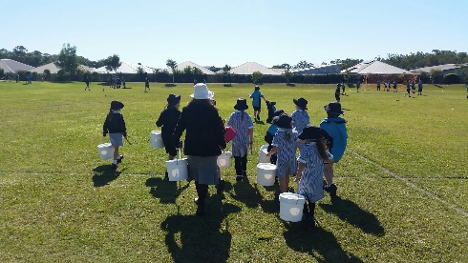 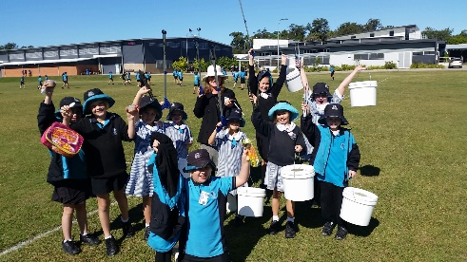

|  |  |  |
| --- | --- | --- |
|  | **Environmental footprint indicators** | |
| Years | Electricity  kWh | Water kL |
| 2011-2012 | 802,704 | 53,719 |
| 2012-2013 | 834,428 | 187,176 |
| 2013-2014 | 846,933 | 38,785 |

The consumption data is compiled from sources including ERM, Ergon reports and utilities data entered into OneSchool by each school. The data provides an indication of the consumption trend in each of the utility categories which impact on the school’s environmental footprint.

|  |
| --- |
| Our staff profile |
|  |

**Staff composition, including Indigenous staff**

|  |  |  |  |
| --- | --- | --- | --- |
| **2014 Workforce Composition** | Teaching Staff* | Non-teaching Staff | Indigenous Staff |
| Headcounts | 166 | 67 | <5 |
| Full-time equivalents | 155 | 48 | <5 |

**Qualification of all teachers**



*Teaching staff includes School Leaders

**Graduate Diploma etc. includes Graduate Diploma, Bachelor Honours Degree, and Graduate Certificate.

**Expenditure on and teacher participation in professional development**

The total funds expended on teacher professional development in 2014 were $83,734.15.

The major professional development initiatives are as follows:

* The Art and Science of Teaching
* Data Analysis and Application
* e-Learning Strategies & Use of Digital Devices
* Literacy
* Mathematics
* Academically Talented
* Early Phase of Learning
* Flying Start – Year 7 curriculum
* Student Wellbeing
* Subject specific training/conferences/seminars

The proportion of the teaching staff involved in professional development activities during 2014 was 100%.

|  |  |  |  |
| --- | --- | --- | --- |
| **Average staff attendance** | 2012 | 2013 | 2014 |
| Staff attendance for permanent and temporary staff and school leaders. | 96% | 96% | 96% |

**Proportion of staff retained from the previous school year**

From the end of the previous school year, 95% of staff was retained by the school for the entire 2014 school year.

**School income broken down by funding source**

School income broken down by funding source is available via the *My School* website at <http://www.myschool.edu.au/>.

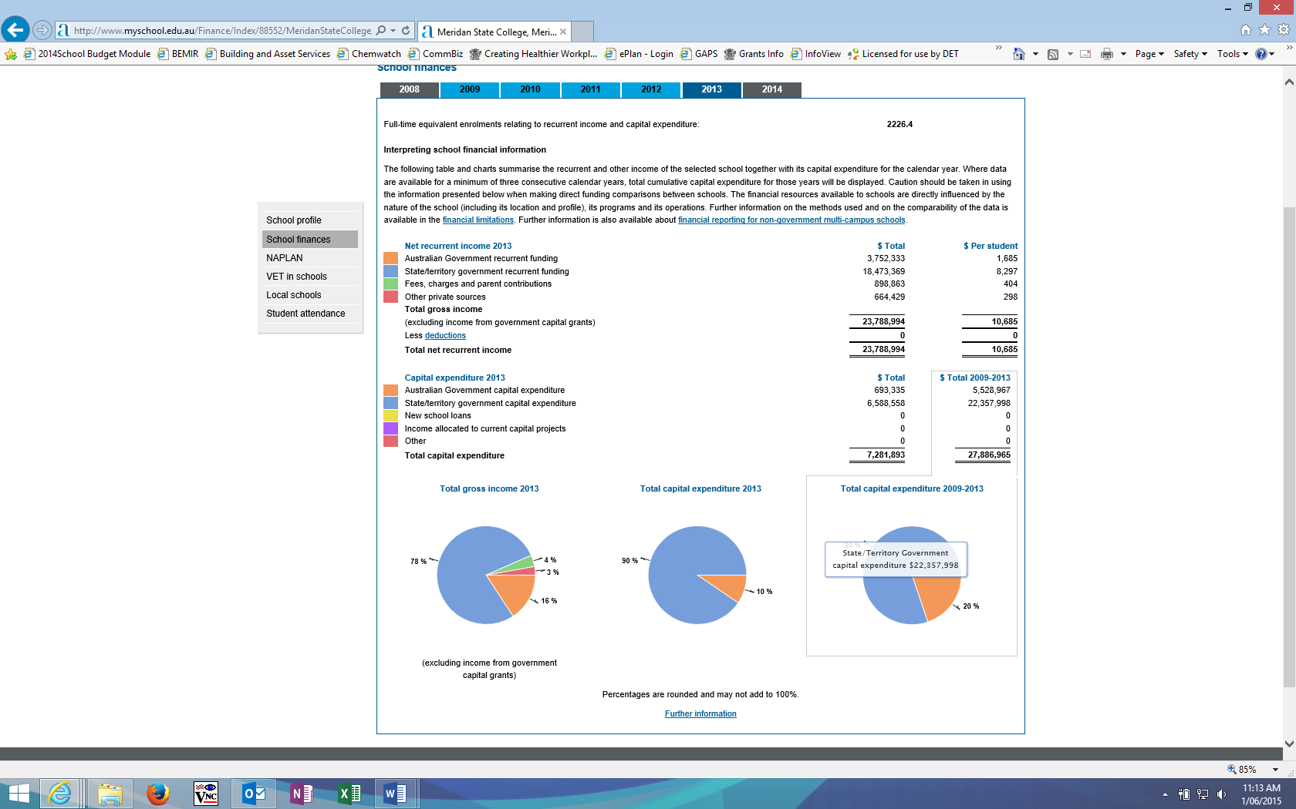

To access our income details, click on the *My School* link above. You will then be taken to the *My School* website with the following **‘Find a school’ text box.**

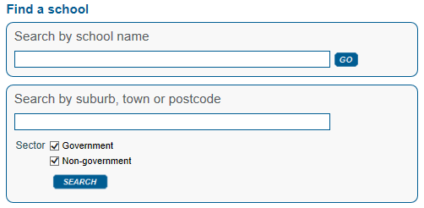

Where it says **‘Search by school name’**, type in the name of the school you wish to view, and select <GO>. Read and follow the instructions on the next screen; you will be asked to accept the **Terms of Use** and Privacy Policy before being given access to the school’s *My School* entry webpage.

School financial information is available by selecting **‘School finances’** in the menu box in the top left corner of the school’s entry webpage. If you are unable to access the internet, please contact the school for a paper copy of income by funding source.

|  |
| --- |
| Performance of our students |
|  |

**Key student outcomes**

|  |  |  |  |
| --- | --- | --- | --- |
| **Student attendance** | 2012 | 2013 | 2014 |
| The overall attendance rate for the students at this school (shown as a percentage). | 92% | 92% | 93% |

The overall attendance rate in 2014 for all Queensland P-10/P-12 schools was 89%.

| **Student attendance rate for each year level (shown as a percentage)** | | | | | | | | | | | | |
| --- | --- | --- | --- | --- | --- | --- | --- | --- | --- | --- | --- | --- |
|  | Year 1 | Year 2 | Year 3 | Year 4 | Year 5 | Year 6 | Year 7 | Year 8 | Year 9 | Year 10 | Year 11 | Year 12 |
| 2012 | 94% | 94% | 94% | 94% | 93% | 92% | 93% | 92% | 91% | 91% | 89% | 90% |
| 2013 | 94% | 93% | 94% | 94% | 93% | 93% | 92% | 93% | 92% | 91% | 89% | 89% |
| 2014 | 95% | 95% | 95% | 95% | 94% | 95% | 94% | 93% | 93% | 92% | 90% | 89% |

DW = Data withheld to ensure confidentiality.

**Student attendance distribution**

The proportions of students by attendance range.



*The method for calculating attendance changed in 2013 – care should be taken when comparing data after 2012 to that of previous years.

**Description of how non-attendance is managed by the school**

Non-attendance is managed in state schools in line with the DETE policies, SMS-PR-029: Managing Student Absences and SMS-PR-036: Roll Marking in State Schools, which outline processes for managing and recording student attendance and absenteeism.

Primary Campus

When students are absent parents will receive a text message that requests they contact the school to explain the student’s absence. By the 3rd day the Deputy will make contact. We strive for 0% unexplained absences in Primary. We also contact parents if their child is consistently late so that we can ensure they have maximum time engaged in positive learning.

Secondary Campus

Student attendance is a key priority for the secondary campus. A number of key practices are in place to address student attendance and maximize school participation including:

* Mentor Class and Session roll marking.
* Text message to parents/carers of absent students.
* 2pm report issued to class teachers to identify and follow-up non-attendance.
* Implementation of year level student managers focused on supporting wellbeing, attendance and performance (Community Leaders, Year Level Mentors).
* 3 day absence reports issued to year level managers to follow-up non-attendance.
* Issuing of 3 day absence letters to parents/carers.
* Late to school and late to class procedures.
* Exemption from Schooling processes.
* Articulated processes for absences for assessment in line with QCAA guidelines.
* Discussion with parents/carers and students as part of Student Performance Conversations.
* Tracking and celebration of positive attendance data – Attendance Club.
* Focus on the importance of attendance in newsletters and information sessions.
* Formal absentee/truancy process.
* Professional Development for staff.

**National Assessment Program – Literacy and Numeracy (NAPLAN) results – our reading, writing, spelling, grammar and punctuation, and numeracy results for the Years 3, 5, 7, and 9.**

Our reading, writing, spelling, grammar and punctuation, and numeracy results for the Years 3, 5, 7 and 9 are available via the My School website at <http://www.myschool.edu.au/>.

To access our NAPLAN results, click on the My School link above. You will then be taken to the My School website with the following **‘Find a school’ text box.**



Where it says **‘Search by school name’**, type in the name of the school whose NAPLAN results you wish to view, and select <GO>.

Read and follow the instructions on the next screen; you will be asked to accept the **Terms of Use** and Privacy Policy before being able to access NAPLAN data. If you are unable to access the internet, please contact the school for a paper copy of our school’s NAPLAN results.

**Achievement – Closing the Gap**

Student Attendance:

Indigenous student attendance in 2014 was 90.7% compared to Non-Indigenous student attendance of 93.5%. Indigenous student attendance was better than that of 2013 and has consistently increased from 2010.

Student Attainment:

Indigenous student attainment in Year 3 was slightly higher in Writing than non-indigenous students but lower in Readying and Numeracy; in Year 5 significantly above non- indigenous students in reading, writing and numeracy; in Year 7 higher in Reading but lower in Writing and Numeracy; and in Year 9 lower in all three domains.

Student Retention:

Student retention from Year 10 to Year 12 was 62.6%, a significant decrease from 2013.

|  |  |  |  |
| --- | --- | --- | --- |
| **Apparent retention rates Year 10 to Year 12** | 2012 | 2013 | 2014 |
| Year 12 student enrolment as a percentage of the Year 10 student cohort. | 75% | 80% | 86% |

| **Outcomes for our Year 12 cohorts** | 2012 | 2013 | 2014 |
| --- | --- | --- | --- |
| Number of students receiving a Senior Statement | 133 | 139 | 150 |
| Number of students awarded a Queensland Certificate of Individual Achievement. | 0 | 0 | 0 |
| Number of students receiving an Overall Position (OP) | 59 | 58 | 80 |
| Number of students who are completing/continuing a School-based Apprenticeship or Traineeship (SAT). | 35 | 18 | 25 |
| Number of students awarded one or more Vocational Educational Training (VET) qualifications (incl. SAT). | 133 | 139 | 150 |
| Number of students awarded an Australian Qualification Framework Certificate II or above. | 132 | 138 | 149 |
| Number of students awarded a Queensland Certificate of Education (QCE) at the end of Year 12. | 131 | 138 | 150 |
| Number of students awarded an International Baccalaureate Diploma (IBD). | 0 | 0 | 0 |
| Percentage of OP/IBD eligible students with OP 1-15 or an IBD. | 85% | 81% | 73% |
| Percentage of Year 12 students who are completing or completed a SAT or were awarded one or more of the following: QCE, IBD, VET qualification. | 100% | 100% | 100% |
| Percentage of Queensland Tertiary Admissions Centre (QTAC) applicants receiving an offer. | 100% | 88% | 96% |

As at 19 February 2015. The above values exclude VISA students.

| **Overall Position Bands (OP)** | | | | | |
| --- | --- | --- | --- | --- | --- |
|  | Number of students in each Band for OP 1 to 25 | | | | |
| Years | OP 1-5 | OP 6-10 | OP 11-15 | OP 16-20 | OP 21-25 |
| 2012 | 12 | 16 | 22 | 9 | 0 |
| 2013 | 8 | 16 | 23 | 10 | 1 |
| 2014 | 8 | 23 | 27 | 21 | 1 |

As at 19 February 2015. The above values exclude VISA students.

|  |  |  |  |
| --- | --- | --- | --- |
| **Vocational Educational Training qualification (VET)** | | | |
|  | Number of students completing qualifications under Australian Qualification Framework (AQF) | | |
| Years | Certificate I | Certificate II | Certificate III or above |
| 2012 | 118 | 131 | 40 |
| 2013 | 123 | 138 | 29 |
| 2014 | 120 | 149 | 38 |

As at 19 February 2015. The above values exclude VISA students.

Meridan State College offer various Certificate courses to students from Year 10, ranging from Certificate1 through to Certificate 3.

Certificate one courses completed by students include Hospitality, Business Education and Technology. Our completion rate for courses across all certificates is outstanding, with 100% of students completing Year 12 in 2014 gaining a Certificate 1 through Certificate 3.

**Post-school destination information**

At the time of publishing this School Annual Report, the results of the 2014 post-school destinations survey, Next Step – Student Destination Report (2014 Year 12 cohort) for the school were not available. Information about these post-school destinations of our students will be uploaded to the school’s website in September.

**Early school leavers information**

Meridan State College encourages students to be involved in work placement, traineeships, school based apprenticeships, and also in the Sunshine Coast Technical Trade training Centre, based at Caloundra. Many of our early leavers in 2014 were fortunate enough to be offered full time positions through these employment avenues. Other students who left Meridan from the Senior School moved interstate and within State for parent employment opportunities.